Video 1.(40 min):

Sudo su –

Useradd vinuth

Passwd vinuth

Su – vinuth

Ctrl d or logout or exit

Date

Cal,cal 02 2022,cal 2022

Ls,ls -l long list,

Man useradd

Touch vinuth laxmi

Mkdir , mkdir -p mobile/{redmi,vivo,realme,nokia}, mkdir -p student{1..9}/{maths,science,physics}

Mkdir /home/laxmi/vinuth vinuth will be created inside laxmi directory

Root user home directory is /root

Normal user home directory is /home/(username)

Ll -a hidden content , ll -h vinuth -human readable form

Cd .

Cd .. - Change Current directory to parent directory.

Cd /root/student1/ ---- absolute patch

Cd student1/ ----------- relative path

Cd ../.. --- take to 2 directory behind .

Cd - --- take to previous directory

Cd / will take to root directory

Cd ~ or cd will take to super user home directory. cd ~vinuth/ will take vinuth’s home directory

Mkdir .vinuth , touch .vinuth ------ create hidden file or directory

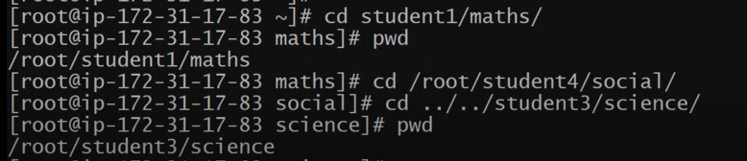

Vi file1

:wq --- write and quite

Sleep or sleep 500

A Tab+tab or B tab+tab

Compgen -c ---- list of commands

Ps -ef --- running process ID’s

Bash is the latest and best shell

Video2

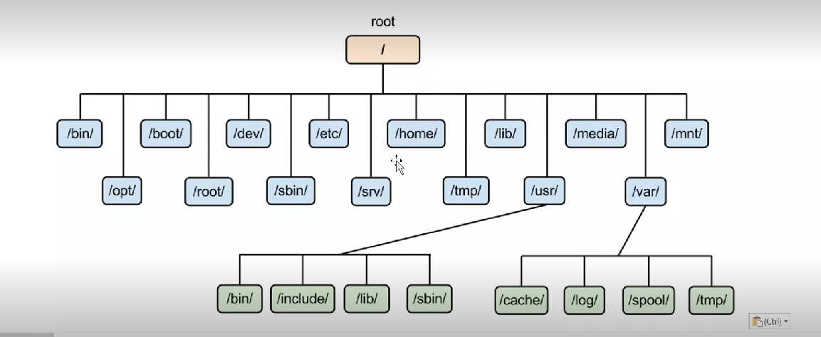

tree we can see directories in tree structure

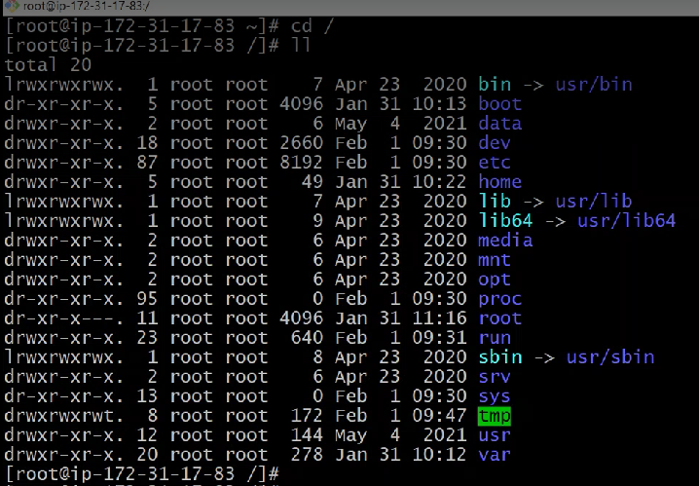

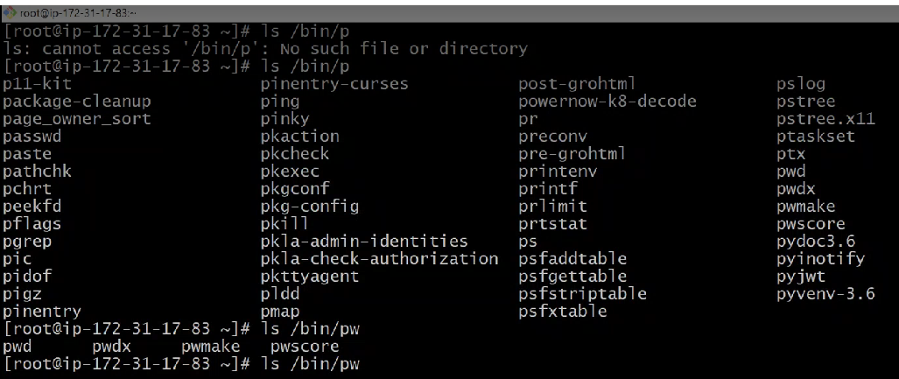

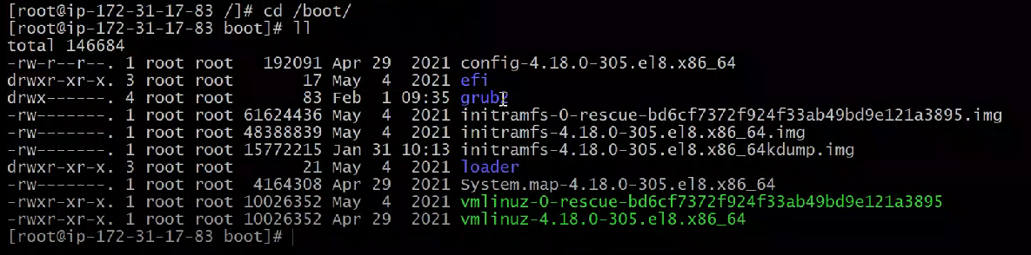

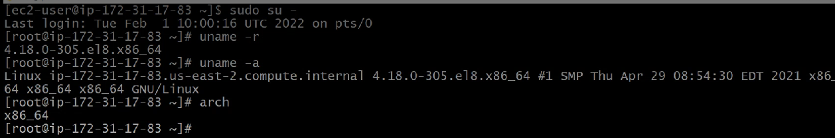

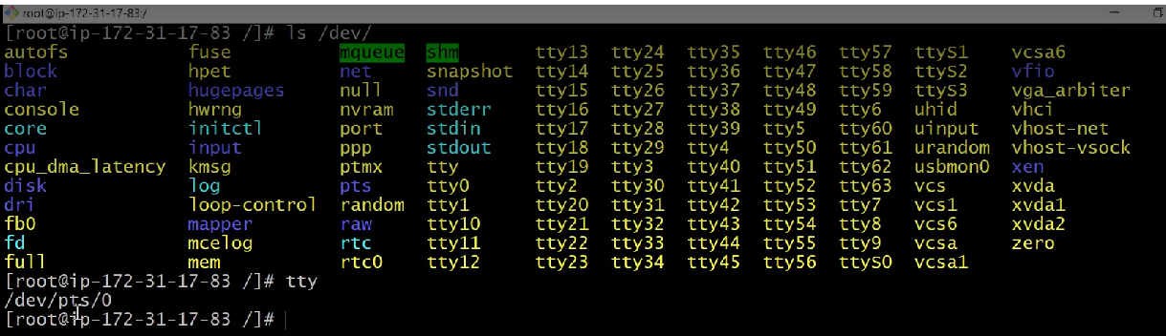

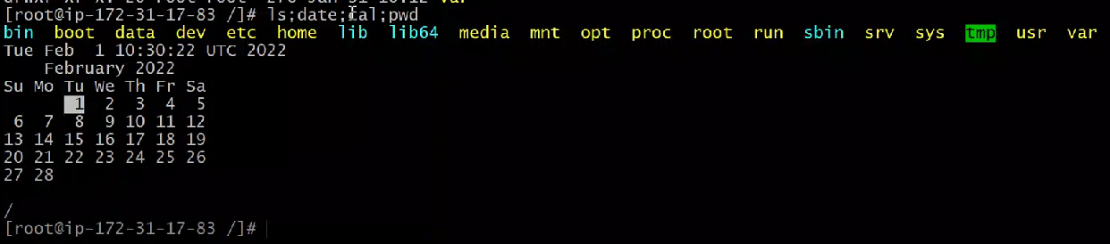

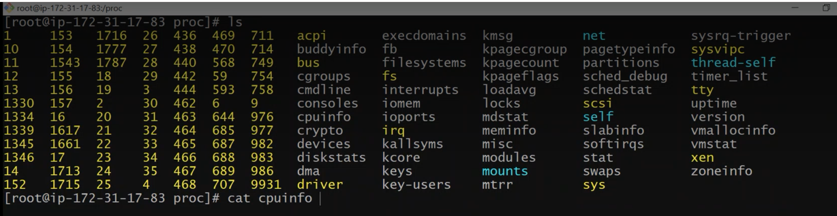

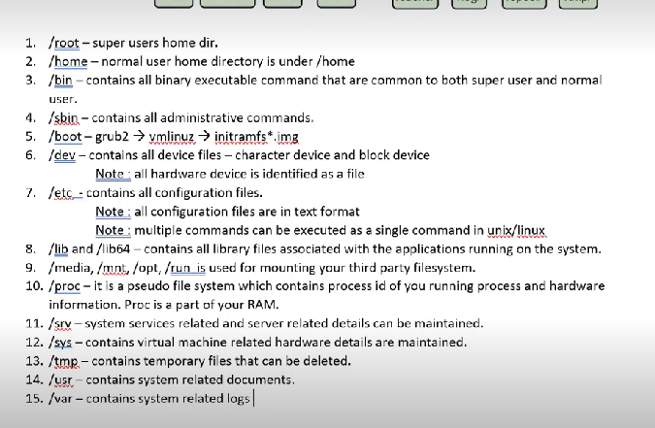

Video3:file system browsing

Cp

Cp f* path

Cp ?u* path or cp ??n* path

Cp file1 file2 file3 path

Copying Directry:

Cp -var * /home/laxmi/vinuth/ copy everything in present working directory to vinuth

Cp /home/laxmi/vinuth/ . for current directory.

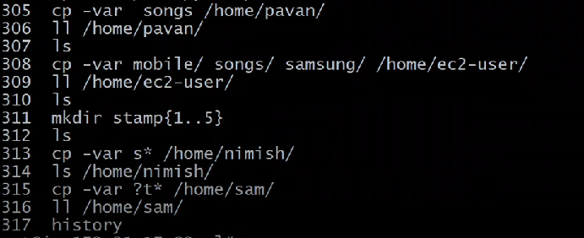

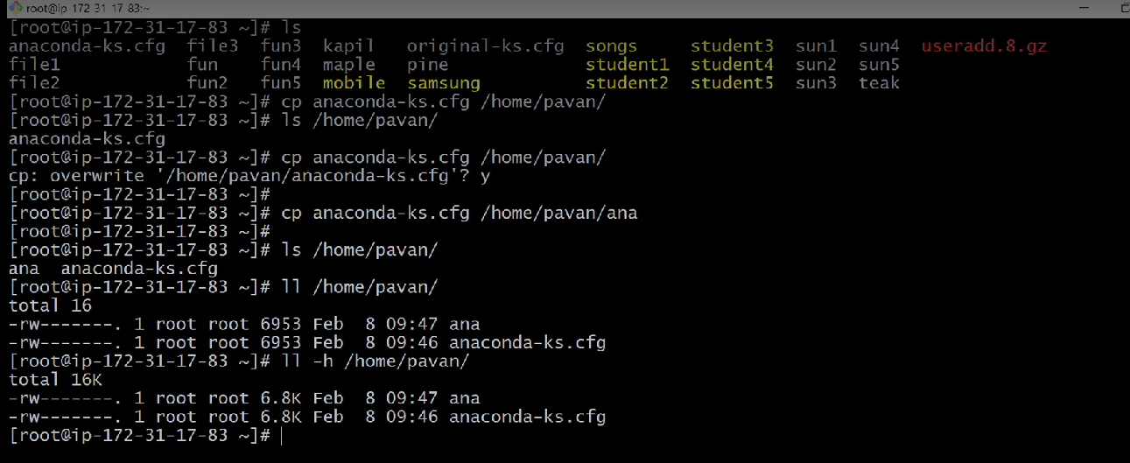

Remove:

rm file1

rm -f file1

rm -f file1 file2 file3

rm -f f*

rm -f ?u*

rm -r laxmi/

rm -rf laxmi/

rm -rf laxmi/ vinuth/

rm -rf s*

rm -rf ??s*

rm -rf *

Move:

mv /home/pavan/rootbackup/* /root/ or mv /home/pavan/rootbackup/* . when we are in present working directory

mv kapil dev it can be used as rename command

Help cammands:

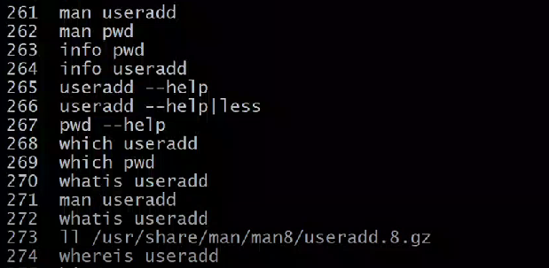

Vi editor:

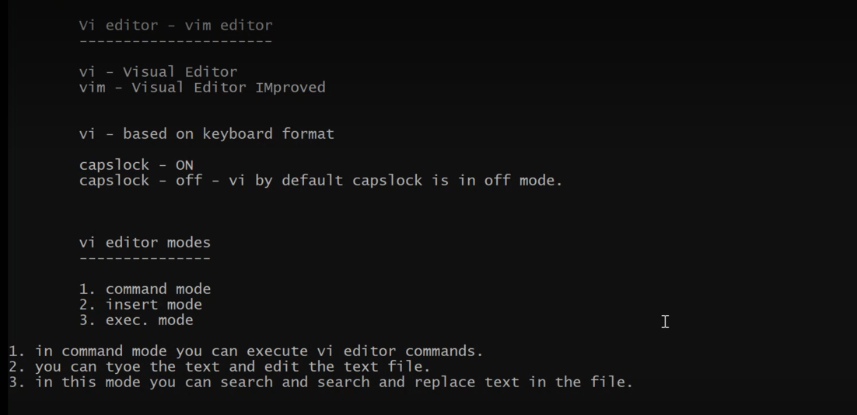

In command mode if we press l crosor will move forward by 1 character. H opposite. J one line down. K one line up. W moves one word forward. :set numbers will assign numbers to each line.

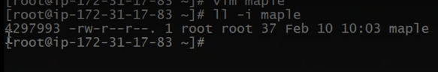

4297993 is an inode number.

Softlink: ln -s maple pamplelink

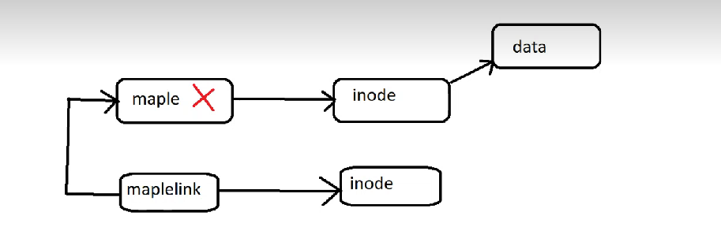

Hardlink: ln teak teaklink

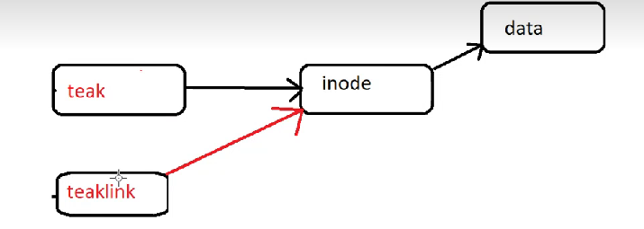

If softlink maple is removed link will be broken.in hardlink teak is removed data will be able to access through teaklink. If teaklink is removed teak also will removed. Hardlink will not work for the directories.

Below is the command to unlink.

Unlink teaklink

Redirectors:

Cat > file1 ctlD

Cal > file1

Cat >> file1 apended

Cat < file1

tr < {a-z} {A-Z} < file1

cp /maple 2> file2 error of the command will copy to the file2

cp /maple 2>> file2 appended

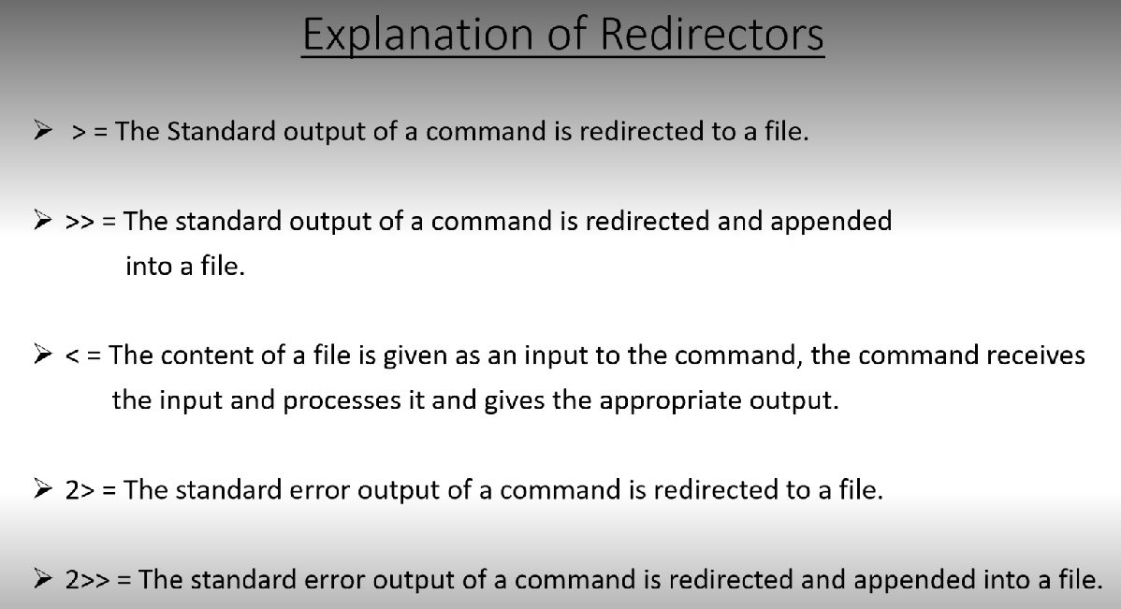

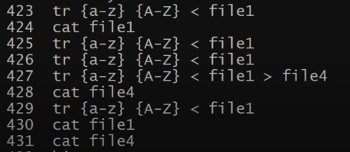

History: ctrl R and search for keyword.

Tar and zip utilities:

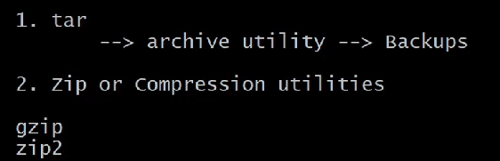

Tar -cvf vinuth.tar vinuth - creating the tar file

Tar -tvf vinuth.tar - to see content of the tar file.

Tar -xvf vinuth.tar – to extract the tar file.

Tar -cvf root.tar * - taking root directory backup.

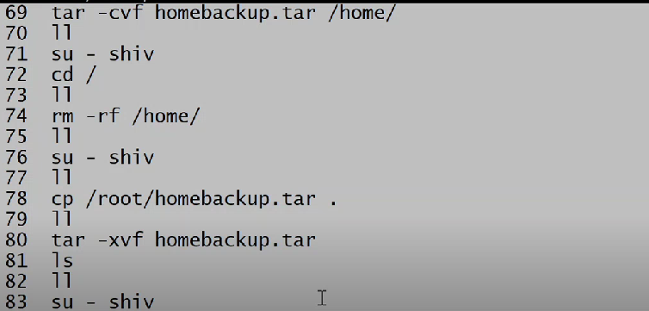

Gzip lastlog

Gunzip lastlog.gz

Bzip2 lastlog

Bunzip2 lastlog.bz2 – bzip2 has ability to compress textfile up to 95%(not only for text file)

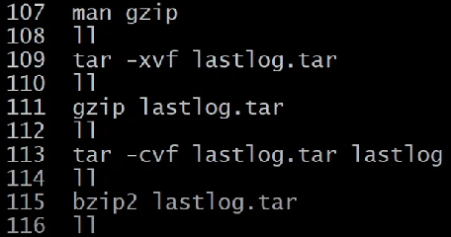

First we tar then we zip vice versa

Below are the single command to tar and zip, unzip.

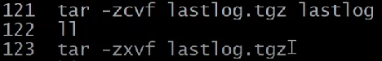

Filesystem:

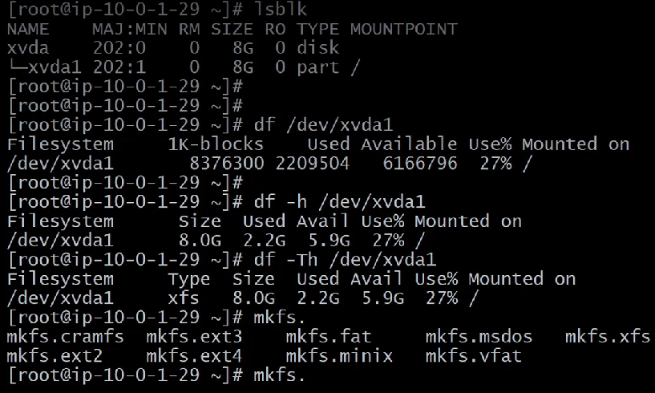

du -h filename - will provide disk usage of the file

du -h /etc provide disk usage of all file in etc

du -sh /etc will provide disk usage of etc alone

User Group and Permissions:



First one is permission second one is linked on 3rd one is userid 4th one is group id 5th size in byte 6th date and time and 7th one is name.



1st 3 for user 2nd 3 for group last 3 for others. Read or right permission may or may not be exist. Like 1 or 0.

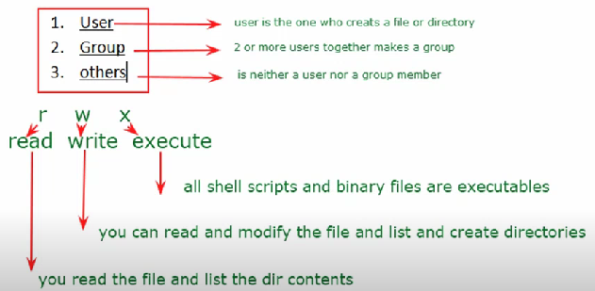

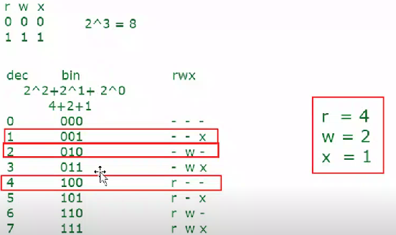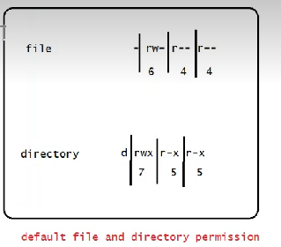

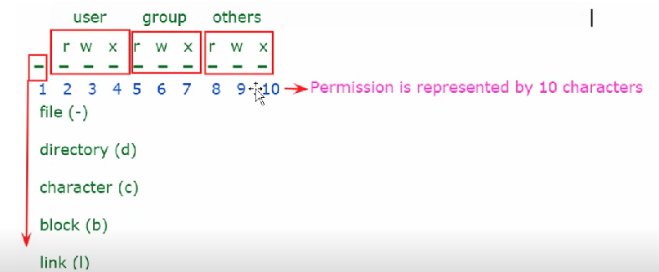

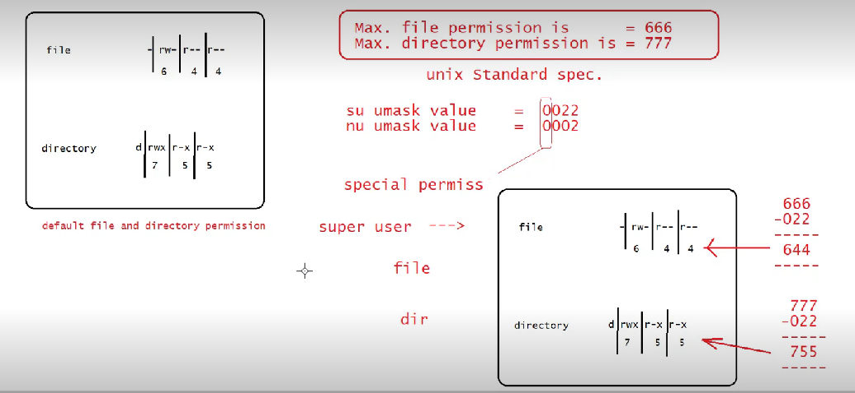

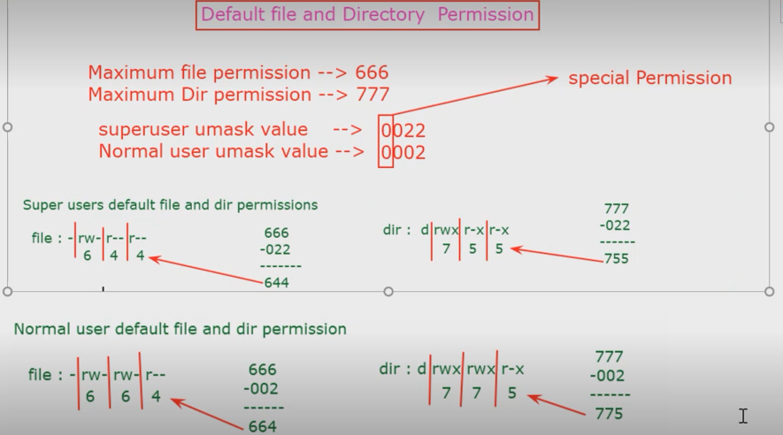

We can see umask by command umask and also we can change permission temporarily by command umask 0000

Commands to change permission:

Chmod ugo+rwx filename

Chmod ugo-rwx filename

Chmod u=rwx,g=rw,o=r filename

Chmod 764 filename chmod -R 764 directory name

When we create a user 3 files are get updated.

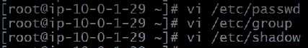

**Cat /etc/passwd**

In passwd file there are 7 fields separated by :



1 st one is user second one is password represented by X 3rd one is user ID 4th one is group ID 5th one is fullname 6th field is home directory last one is shell. any user ID below thousand are the system created user abow thousand is administrator created users.

**Cat /etc/group**

Every time we create user group will be created called primary group.



1st field is user 2nd password 3rd group ID 4th group member

Commands:

Groupadd sales

Usermod -G sales vinuth – adding user to the group

Useradd -G sales vinuth -- creating user and adding to the group

Usermod -s /bin/nologin vinuth ---- to disable access. Vinuth will be in nologin shell.



 to enable access.

Chgrp sysadmin /sysadmin/ ---- changing the group of /sysadmin

Chmod g+s /sysadmin/ -- to carry the group inharitance

**Cat /etc/shadow**

It has 8 field



1st one is user 2nd is encrypted password 3rd to 8th is account and password expiry

Practice:

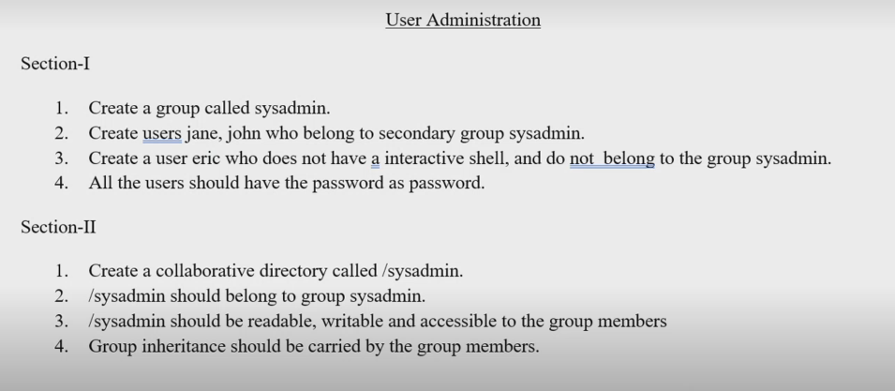

**Special Permissions:**

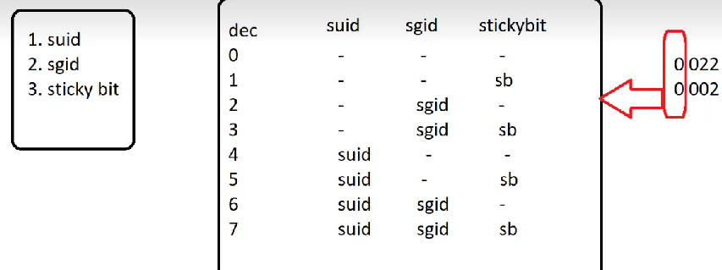

Setting stickybit will allow you to create own file and delete own file

Chmod 1745 directory name

Setting sgid will allow group concurrency

Chmod 2745 directoryname

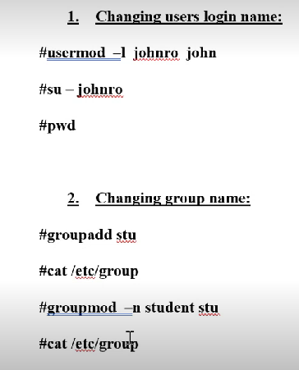

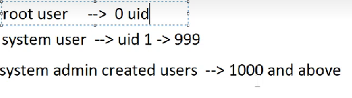

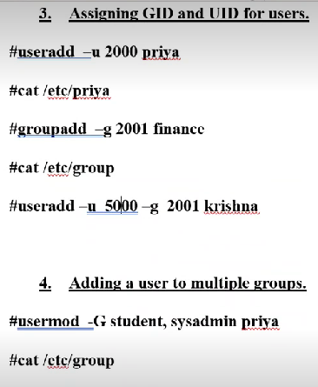

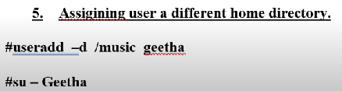

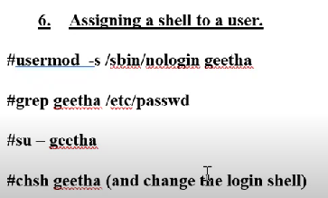

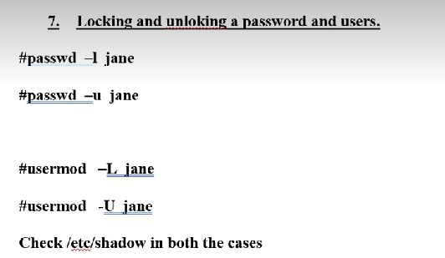

In shadow file locking user will have single ! locking password will have double !!

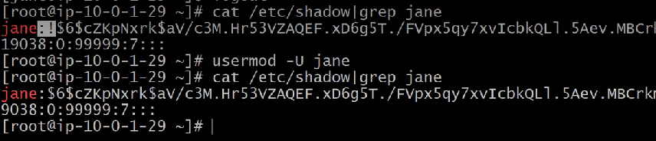

**Changing date and time:**



**Setting up password aging for a user:**

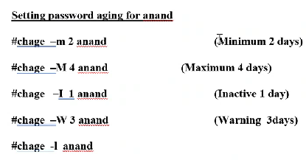

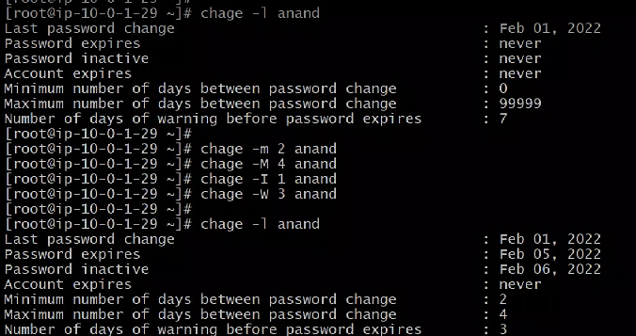

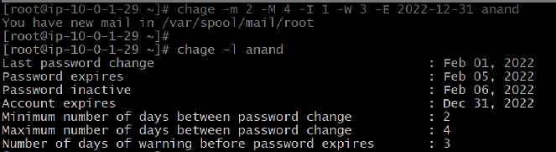

-E for account expiry

**SUDO: super user do**

Sudoers file one for read we can provide sudo access through the command visudo



First all for login from any terminal second ALL for access to all commands 3rd ALL for login as any user



This will provide privilege to do only execute user administrator commands.

**Setting ACL for files and directories:**

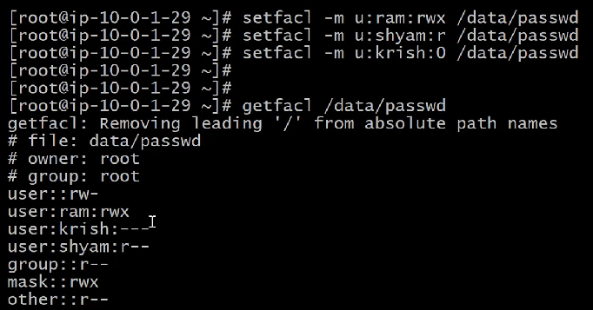

**Disc Management:**

In RHEL default file system is XFS

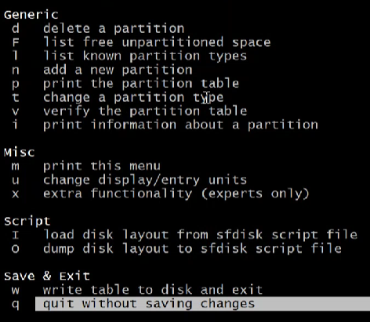

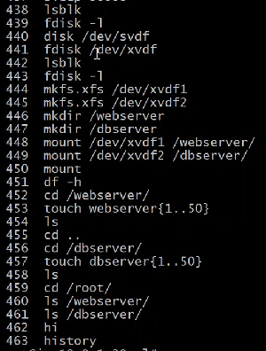

Lsblk – to list the blocks or fdisk -l

Mkfs.xfs /dev/xvdf1 -- to create file system for xvdf1

Mkdir /webserver – to create mountpoint for xvdf1

Mount /dev/dvdf1 /webserver/ - to mount

Df -h

Df -h /dev/xvdf1 - to check indivisually

Df -h /dev/xvdf1 - to know the filesystem

Once we reboot the servers above mount will be unmount it’s a not a permanent mount.

**Auto mounting through fstab:**

Vi /etc/fstab

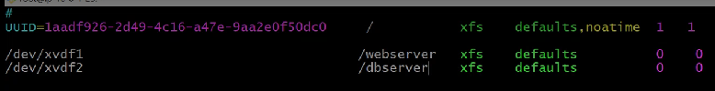

0 is the file system check no need to provide

Mount -a -- permanent mount is done or mount /apps/new-volume /dev/xvdf

:!!blkid /dev/xvdf1 - to get UUID in fstab

**Managing SWAP:**

Swap is a hard disk space acting like a ram. its a virtual memory in addition to ram.

Free -h -- to check ram space

Swap is double the space for ram.

Lsblk

Mkswap /dev/xvdg -- creating the filesystem for swap

Vi /etc/fstab

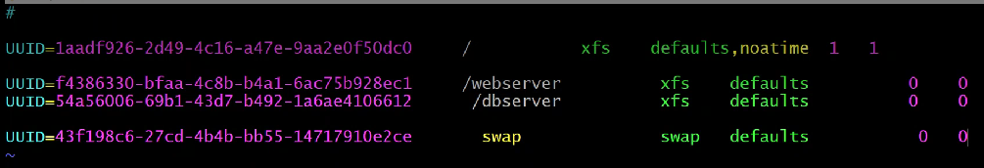

Swapoff -a

Mount -a

Swapon -a

Free -h

**Adding extra swap:**

Dd if=/dev/zero of=/root/swapfile bs=1G count=1 --- it will create swapfile in root home directory also we can change count and bs

Swapoff -a

Mkswap swapfile

Vi /etc/fstab

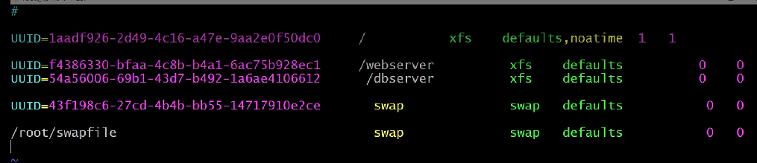

Mount -a

Swapon -a

Free -h

**Logical volume Manager(LVM):**

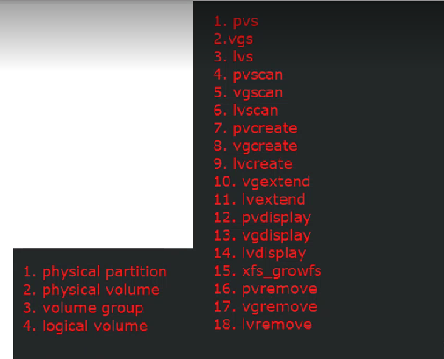 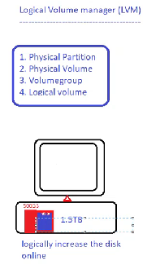

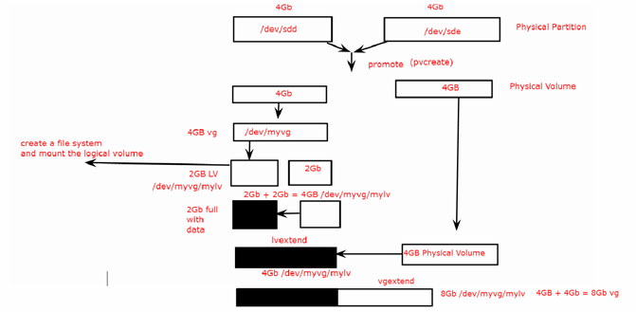

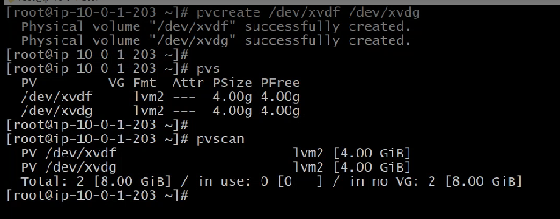

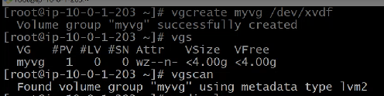

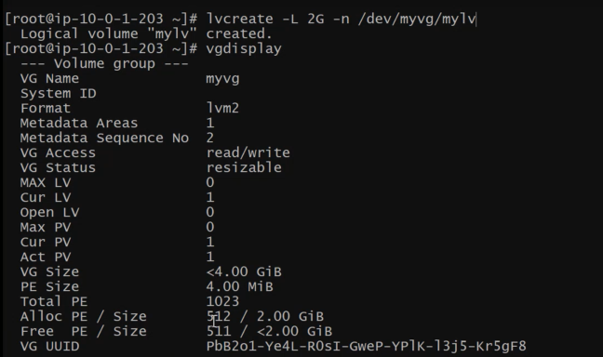

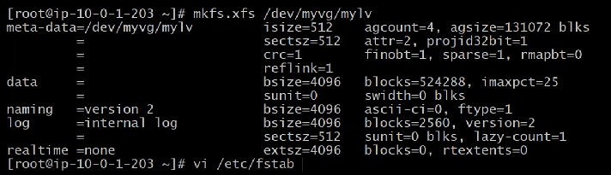

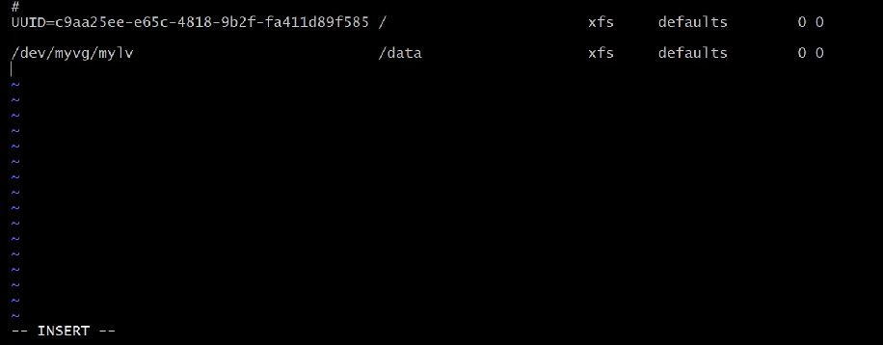

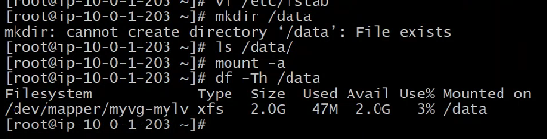

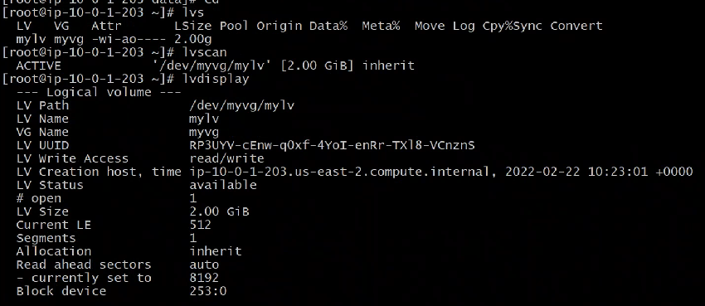

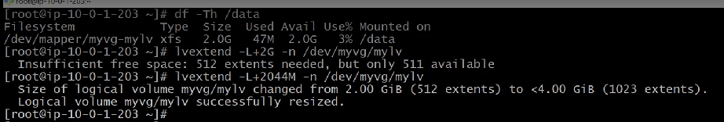

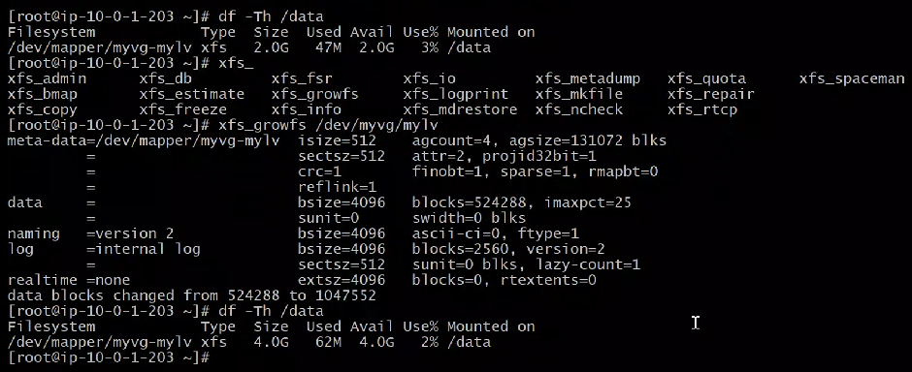

Adding another 4 GB

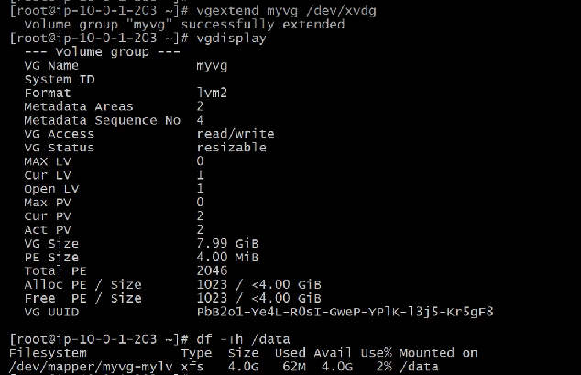

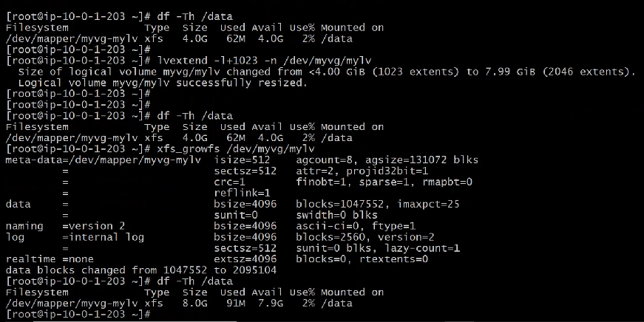

Releasing:

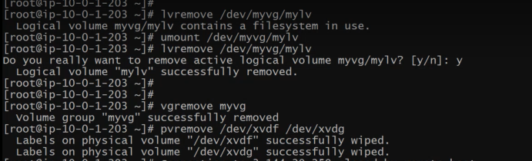

Scheduling of task: AT and Cron and targets

**Process management in unix/linux:**

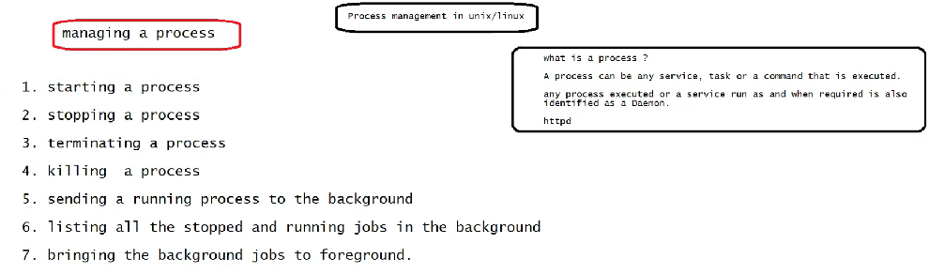

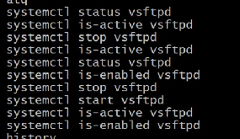once we enable the process it will start automatically when we restart the server.

Ps -ef -- to see all running process

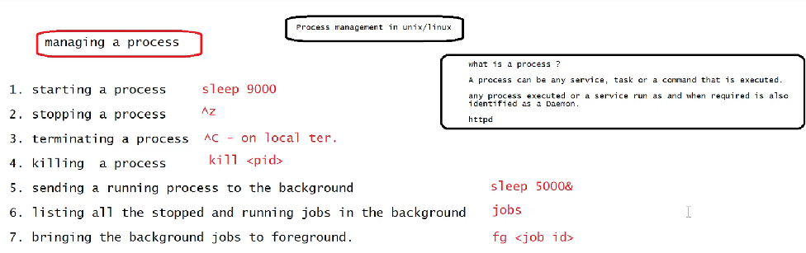

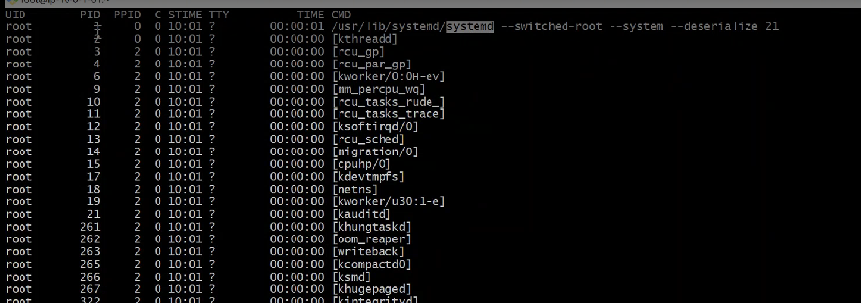

In above screenshot the 1st process systemD is parent of all process. It is the 1st process which start after the system start.

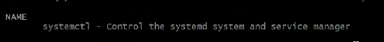

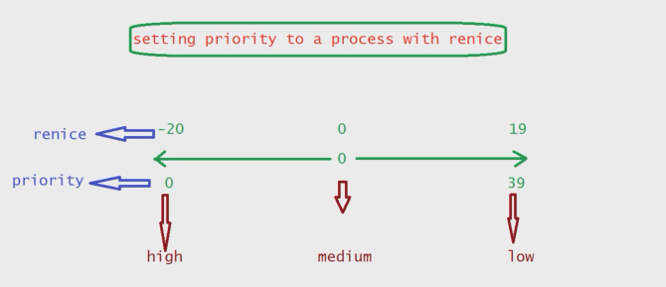after enter top command we can change the priority by entering R or below command.

Renice -n 19 -p <pID>

**String Processing:**

Head file1 – display 1st ten line of file 1

Head -15 file1 --- display 15 lines

 -- pipe symbol combine two commands



Tail file1 ---- display last 10 lines



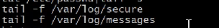----- we can monitor

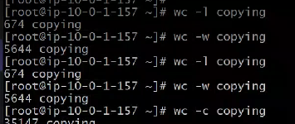-- word count

Rpm -qa ---- packages installed in the system

Rpm -qa |wc -l --- to get number of packages installed

Rpm -qa |sort - -- sort the packages in alphabetical order

Rpm -qa |sort > rpmsort

Cat file1 |grep software ---- to find particular string

Cat file1 |grep -c software -- count

Cat file1 |grep -ci software – ignore case sensitivity or Cat file1 |grep -i software

Cat file1 |grep -v software – v means invers its means lines other than software

Uniq file1 --- omit the repeated lines

Diff file1 file2 -- differentiate between two files

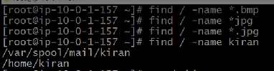-- to find directory or file

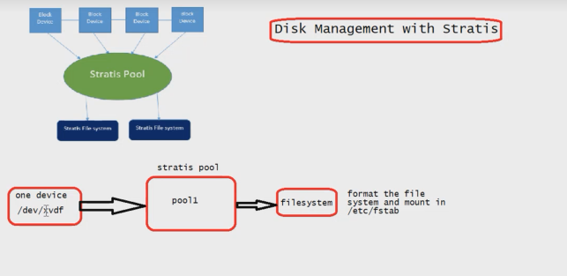

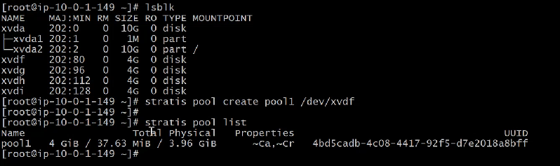

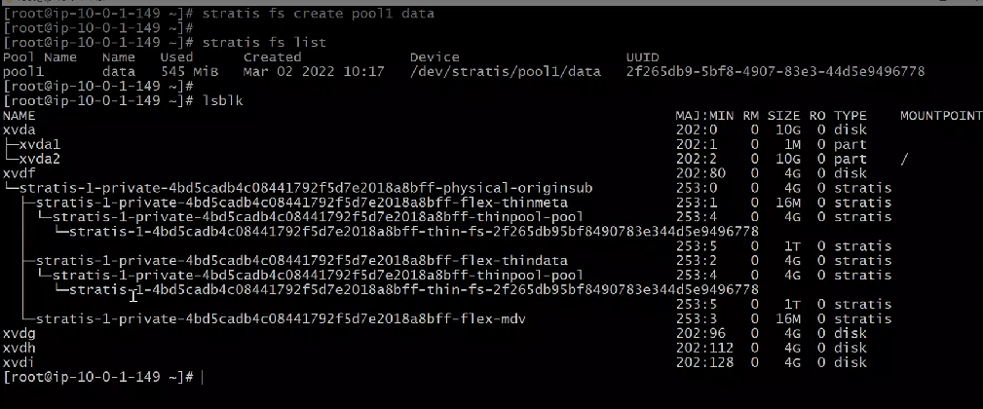

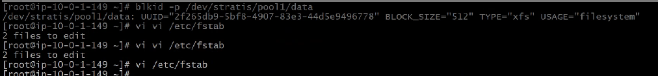

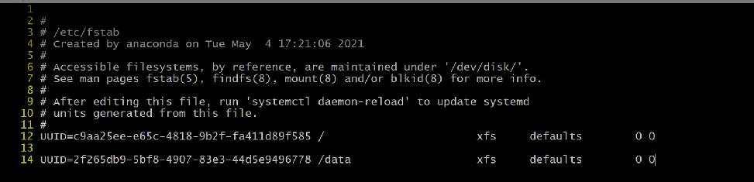

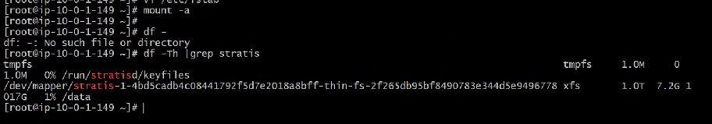

Here smaller memory showed as a larger memory and repeated data will be written single time

NETWORKING:

1.Ifconfig: The ifconfig command **must be used at system startup to define the network address of each interface present on a system**.

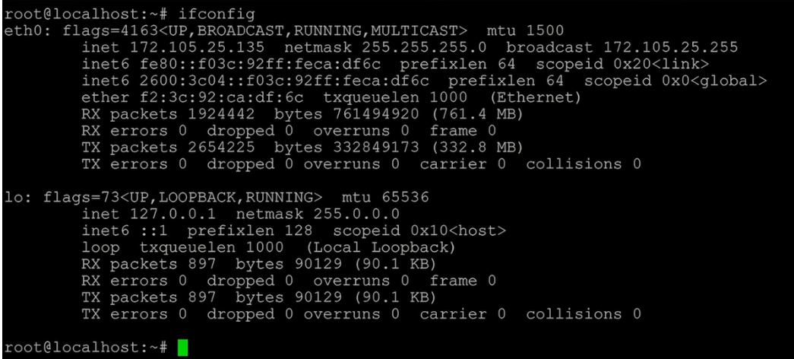

2.to know IP address of the system:

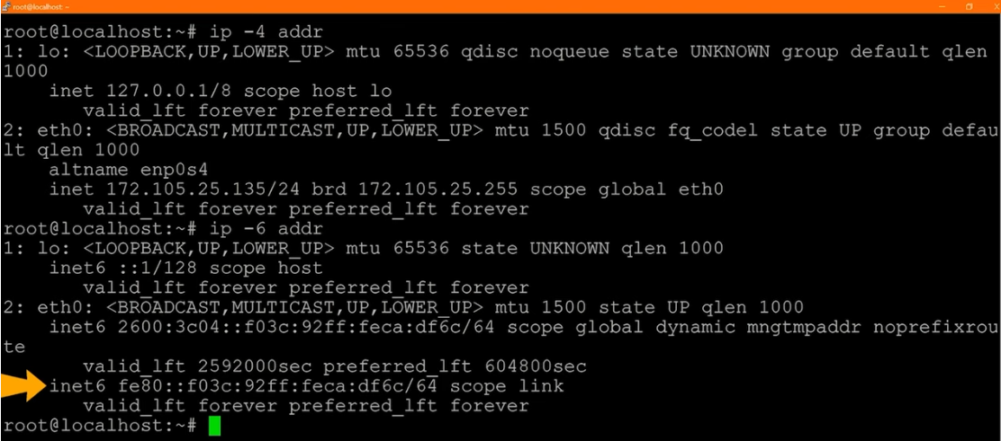

3.netstat: entire network connectivity of the system.

Netstat -a : show all tcp and udp listening port

Netstat -at :show all tcp listning ports

Netstat -l : show all active ports

Netstat -u : all udp ports

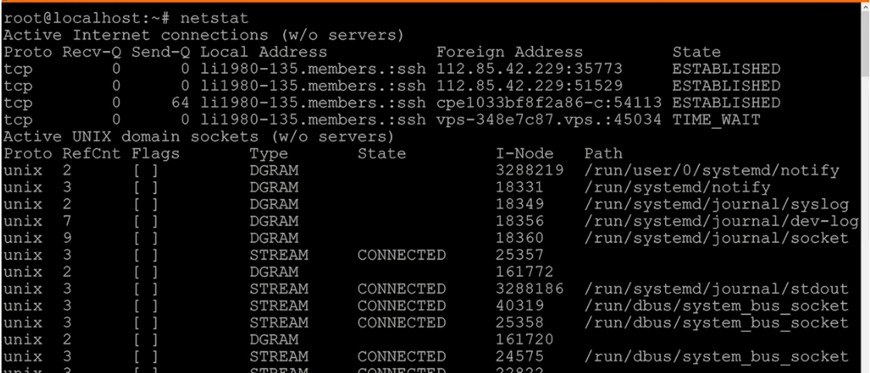

4.curl :to get response from the server. Curl url

5. ping IP or URL : It works by sending a series of Internet Control Message Protocol (ICMP) messages to the target host and waiting for an ICMP echo message from and to the host and Device.

6.telnet 10.07.68.08 80 : to check whether port is opened or not

7.nslookup google.com : nslookup is a network administration command-line tool for querying the Domain Name System to obtain the mapping between domain name and IP address, or other DNS records.

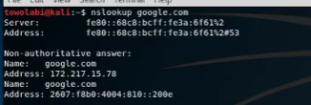

8.tracert: **roubleshooting large networks where several paths can lead to the same point or where many intermediate components (routers or bridges) are involved**.

